**Microprocessor Lab**

Laboratory ActivityNo. 1

**Familiarization with TinkerCAD**

|  |
| --- |
|  |

Score

*Submitted by:*

**Sanchez, John Aris H.**

**<Saturday 10am-1pm> / <Microprocessor 412-1>**

*Date Submitted*

**19-09-2023**

*Submitted to:*

**Engr. Maria Rizette H. Sayo**

1. Exercise

a. A process in Tinkercad where we can develop electronic circuits that can be quickly updated,modified and tested is called rapid prototyping.

b. In Tinkercad, simulation tests the working of the circuits and the components.

c. The device used to assemble and connect the various components is known as breadboard

d. In an electronic circuit with LED, the positive end of the circuit should be connected to

anode and negative end should be connected to cathode of the LED.

e. A resistor is used to restrict the flow of current to electrical components

2. Label the following:



1. Anode and Cathode in a LED

The one which is bent or longer is the anode while the straight or the shorter one is the cathode

1. Different parts of breadboard
2. Is the terminal strips which are the 5 hole rows
3. Bus strips is 2 vertical rows which you connect the power

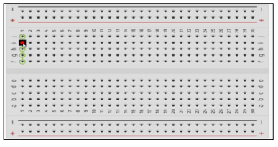

1. List the electronic components used in a circuit assembly

* Resistors
* Capacitors
* Diodes
* Transistors
* LED
* Switches
* Power sources
* Arduino boards
* Micro controllers
* IC
* Sensors
* Buzzers